**Project Report Template**

**Title of Project:** **"Safe & Secure Homes for All"**  
**Name of the Innovator:** Paluri Vinod Reddy  
**Start Date:** 01-09-2025

**End Date: 04-09-2025**

***Day 1: Empathise & Define***

*Step 1: Understanding the Need*

* Which problem am I trying to solve?

“Many people don’t have a safe place to stay and often don’t know where to find help. My project aims to connect them quickly with nearby shelters and support services so they can stay safe and get the help they need.”

* Who is affected by this problem?
* How did I find out about this? [Select whichever is applicable]
* Interviews
* Observation
* Online Research
* AI Tools

*Step 2: What is the problem?*

“Homeless people often struggle to find safe shelters and essential services because information is scattered and hard to access.”

Why is this problem important to solve?

“This problem is important because everyone deserves a safe place to stay. Helping people find shelters and support quickly can protect their health, safety, and well-being.”

**Take-home task**

Ask 2-3 people what they think about the project:

**(Friend):**  
*"I think this project is really helpful. It gives people in need a quick way to find shelters and support."*

**(Family Member):**  
*"This is a meaningful idea. It could make a big difference for people who don’t know where to go for help."*

**(Teacher/Mentor):**  
*"The project is strong and practical. I like that it uses technology to solve a real-world problem, but make sure it’s easy for everyone to use."*

*AI Tools you can use for Step 1 and 2:*

**AI Tools Used:**

• **Chatbot:** Talks to users and answers questions.

• **NLP (Language Understanding):** Understands what users ask.

• **Maps & Location AI:** Shows directions to shelters and NGOs.

• **Database & Analytics:** Keeps info updated and improves suggestions.

***Day 2: Ideate***

*Step 3: Brainstorming solutions*

• **AI Chatbot:** Helps users ask for nearby shelters and services.

• **Location-Based Recommendations:** Shows the closest shelters on a map.

• **Central Database:** Keeps info about shelters and NGOs updated.

• **Personalized Help:** Suggests services based on individual needs.

• **Feedback System:** Lets users report issues to improve the service.

*Step 4: My favourite solution:*

“The AI chatbot is my favorite solution because it gives people in need a simple way to find nearby shelters and support quickly, safely, and easily.”

• **Easy to Use:** People can ask questions in simple language or voice.

• **Quick Help:** Provides real-time info about shelters and NGOs.

*Step 5: Why am I choosing this solution?*

“I’m choosing the AI chatbot because it gives people in need quick, easy, and safe access to shelters and support, helping them find help when they need it most.”

*AI Tools you can use for Step 3-5:*

**AI Tools for Step 3–5**

**Data Collection:**

* **Database & Analytics:** Stores updated shelter and NGO info.
* **Web Scraping / APIs:** Gathers info from websites and public sources.

**Recommendation System:**

* **AI Engine:** Suggests nearest and most suitable shelters.
* **NLP (Language Understanding):** Understands user questions.
* **Maps & Geolocation AI:** Finds directions and distance to shelters

**– User Interaction:**

* **Chatbot / Conversational AI:** Lets users ask questions naturally.
* **Feedback System:** Collects user input to improve recommendations.

*AI Tools you can use for the take-home task:*

**Canva AI/CoPilot AI/Meta AI:** Use these mobile-based tools to generate images for the solution they want to design

***Day 3: Prototype & Test***

*Step 6: Prototype – Building my first version*

What will my solution look like?

• **Simple Chatbot:** Users can ask questions easily.

• **Shows Nearby Shelters:** Displays locations and directions.

• **Provides Contact Info:** Gives phone numbers and emails for NGOs.

• **Accessible Anywhere:** Works on phones and computers.

• **Quick Help:** Lets people find support fast.

**Design Style:**

• **Simple and Clean:** Easy to navigate with minimal clutter.

• **Friendly Interface:** Warm colors and clear icons make it approachable.

• **Accessible:** Works on phones, computers, and messaging apps.

• **Interactive:** Users can type or speak questions naturally.

**Prototype Tools:**

• **Chatbot Platform:** Dialogflow, Rasa, or Microsoft Bot Framework.

• **Maps & Geolocation:** Google Maps API for directions and distances.

• **Database:** Stores shelter and NGO information.

• **NLP Tools:** Understand user questions.

• **Feedback System:** Collects user input to improve the chatbot.

What AI tools I finally selected to build this solution?

1. **Chat GPT**
2. **Metamgx**

**< Build The Innovation>**

**<DASHBOAD OF THE TOOL>**

**Tool Link** **https://mgx-rcgtj0j6en.mgx.world**

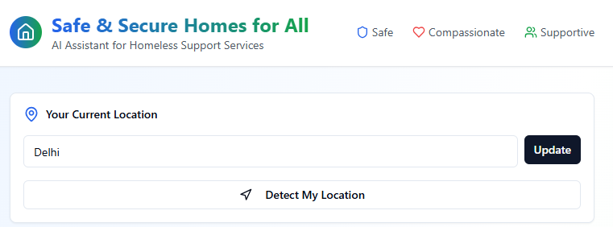

virtual assistant: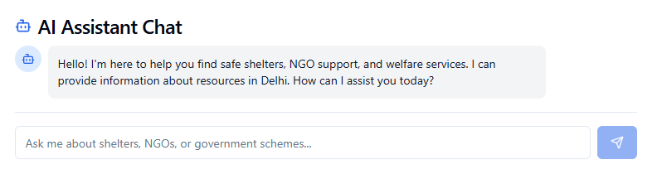

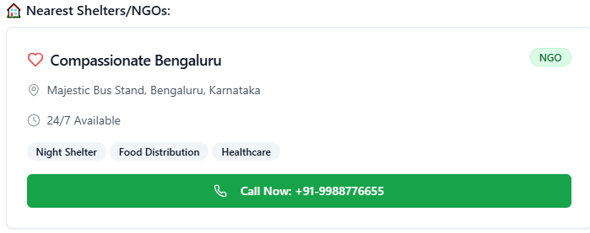

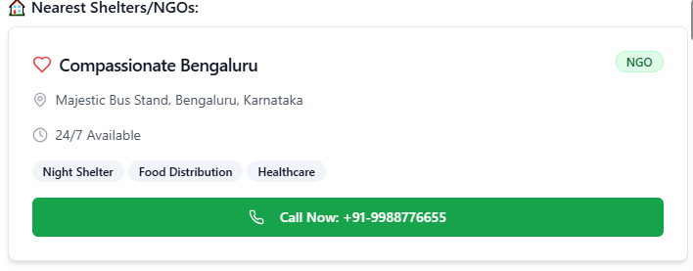

*Step 7: Test – Getting Feedback*

* Who did I share my solution with?

I shared my **safe and Secure** solution with:

• Shared with **friends** for their opinions.

• Shared with **family members** to get feedback.

• Shared with a **teacher/mentor** for guidance and suggestions.

What feedback did I receive?

• **Helpful Idea:** People said the project could really help those in need.

• **Practical Solution:** They liked that it uses technology to connect users with shelters quickly.

• **Ease of Use:** Suggested making it simple and easy for everyone to use, even with little tech experience.

• **Improvement Tips:** Advised adding features like personalized recommendations and real-time updates.

**My Response for The Feedback:**  
“I appreciated the feedback and will make the chatbot simple to use, add personalized recommendations, and ensure real-time updates so it can help people find shelters quickly and easily. I will also focus on making the interface friendly and accessible for everyone, even those with little tech experience. Additionally, I plan to regularly update the shelter and NGO information to keep it accurate and reliable.”

👍 What works well:

• **Easy to Use:** Users can quickly ask questions and get answers.

• **Quick Recommendations:** Shows nearby shelters and services instantly.

• **Helpful Information:** Provides addresses, directions, and contact details.

• **Accessible:** Works on phones, computers, and messaging apps.

• **User Interface:** Make it even simpler and more intuitive for everyone.

• **Real-Time Updates:** Ensure shelter availability and contact info are always current.

• **Accessibility:** Add features for users with limited tech experience or disabilities.

• **Personalization:** Improve recommendations based on individual needs like gender or special accommodations.

• **Feedback System:** Make it easier for users to report issues or suggest improvements.

🔧 What needs improvement

*AI Tools you can use for Step 6-7:*

**Chatbot Platform Analytics:** Track user interactions to see how well the bot responds.

• **Machine Learning Models:** Improve recommendations based on user behavior.

• **Data Analytics Tools:** Analyze usage patterns to make the system smarter.

• **NLP Improvements:** Enhance the chatbot’s understanding of different questions and phrases.

• **Database Updates:** Keep shelter and NGO information accurate and up-to-date.

***Day 4: Showcase***

*Step 8: Presenting my Innovation:*

“My innovation is an AI-powered chatbot that helps people in need find nearby shelters and support services quickly and easily. It provides directions, contact information, and personalized recommendations, making it simple for anyone to access help safely.”

• **AI Chatbot:** Helps users ask questions and get answers easily.

• **Nearby Shelters:** Shows locations and directions to shelters.

• **Contact Info:** Provides phone numbers and emails for NGOs.

• **Personalized Help:** Suggests services based on individual needs.

*Step 9: Reflections*

* What did I enjoy the most during this project-based learning activity?

“I enjoyed creating a solution that can help people in real need the most. It was exciting to design an AI chatbot that makes finding shelters and support easy, and I loved seeing how technology can make a positive impact in people’s lives.”

What was my biggest challenge during this project-based learning activity?

“My biggest challenge was figuring out how to make the chatbot simple and easy to use for everyone, while also providing accurate and up-to-date information about shelters and support services.”

**Take-home task**

*AI Tools you can use for Step 8:*

**Machine Learning Models:** Continuously improve recommendations based on user behavior.

**Chatbot Platform Analytics:** Track how users interact with the chatbot.

**Database Management:** Keep shelter and NGO information updated and accurate.